**04 - Iteration Control Structures**



**Department of Computer Science and Engineering | Rajalakshmi Engineering College**

**.**

**Ex. No.** **: 4.1** **Date: 12.04.2024**

**Register No.: 231401100** **Name: Shree Harini S**



**Factors of a number**

**Determine the factors of a number (i.e., all positive integer values that evenly divide into a number).**

**For example:**

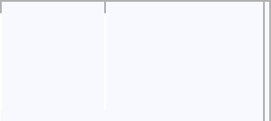

 **Inpu**  **Result**

**t**



**20** **124510**

**20**

**k=int(input())**

**l=[]**

**for i in range(1,k+1):**

**if(k%i==0):**

**l.append(i)**

**for j in l:**

**print(j,end=' ')**



**Department of Computer Science and Engineering | Rajalakshmi Engineering College**

**.**

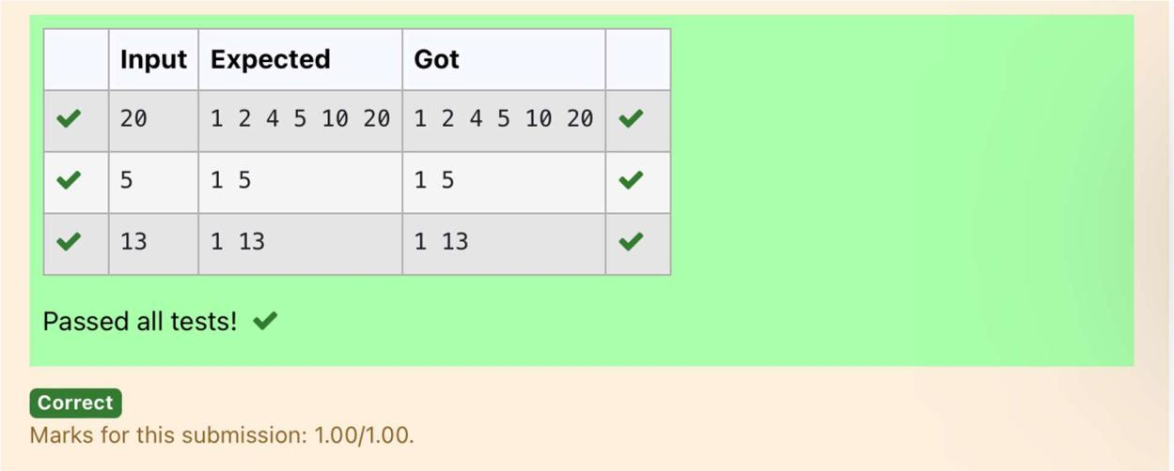

**Department of Computer Science and Engineering | Rajalakshmi Engineering College**

**.**



**Ex. No.** **:** **4.2** **Date: 12.04.2024**

**Register No.: 231401100** **Name: Shree Harini S**



**Non Repeated Digit Count**

**Write a program to find the count of non-repeated digits in a given number N. The number will be passed to the program as an input of type int.**

**Assumption: The input number will be a positive integer number >= 1 and <= 25000.**

**Some examples are as below.**

**If the given number is 292, the program should return 1 because there is only 1 non-repeated digit '9' in this number**

**If the given number is 1015, the program should return 2 because there are 2 non-repeated digits in this number, '0', and '5'.**

**If the given number is 108, the program should return 3 because there are 3 non-repeated digits in this number, '1', '0', and '8'.**

**If the given number is 22, the function should return 0 because there are NO non-repeated digits in this number.**

**For example:**

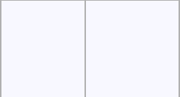

|  |  |
| --- | --- |
| **Input** | **Resul** |
|  | **t** |
| **292** | **1** |
| **1015** | **2** |
| **108** | **3** |
| **22** | **0** |



**n=int(input())**

**l=[]**

**k=[]**

**while n>0:**

**a=n%10**

**n=n//10**

**l.append(a)**

**for i in range(len(l)):**

**if l.count(l[i])==1:**

**k.append(l[i])**

**print(len(k))**



**Department of Computer Science and Engineering | Rajalakshmi Engineering College**

**.**

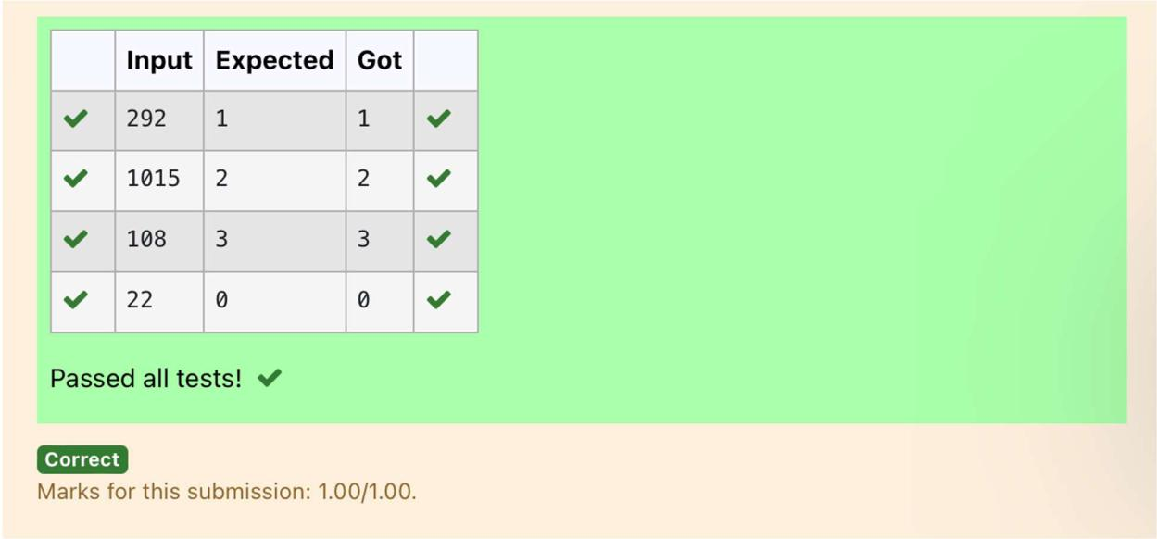

**Department of Computer Science and Engineering | Rajalakshmi Engineering College**

**.**



**Ex. No.** **:** **4.3** **Date: 12.04.2024**

**Register No.: 231401100** **Name: Shree Harini S**



**Prime Checking**

**Write a program that finds whether the given number N is Prime or not. If the number is prime, the program should return 2 else it must return 1.**

**Assumption: 2 <= N <=5000, where N is the given number.**

**Example1: if the given number N is 7, the method must return 2**

**Example2: if the given number N is 10, the method must return 1**

**For example:**



|  |  |
| --- | --- |
| **Input** | **Result** |
| **7** | **2** |
| **10** | **1** |



**a=int(input())**

**for i in range(2,a):**

**if(a%2==0):**

**flag=0**

**elif(a%i!=0):**

**flag=1**

**else:**

**flag=0**

**if(flag==1):**

**print("2")**

**elif(flag==0):**

**print("1")**



**Department of Computer Science and Engineering | Rajalakshmi Engineering College**

**.**

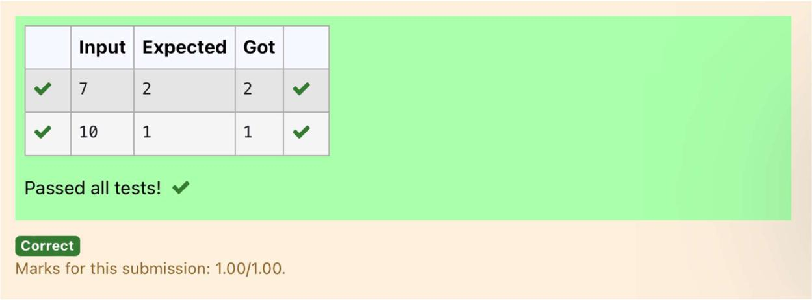

**Department of Computer Science and Engineering | Rajalakshmi Engineering College**

**.**



**Ex. No.** **:** **4.4** **Date: 12.04.2024**

**Register No.: 231401100** **Name: Shree Harini S**



**Next Perfect Square**

**Given a number N, find the next perfect square greater than N.**

**Input Format:**

**Integer input from stdin.**

**Output Format:**

**Perfect square greater than N.**

**Example Input:**

**10**

**Output:**

**16**

**a=int(input())**

**c=[]**

**for i in range(0,a):**

**b=i**2**

**if(b>a):**

**c.append(b)**

**print(c[0])**

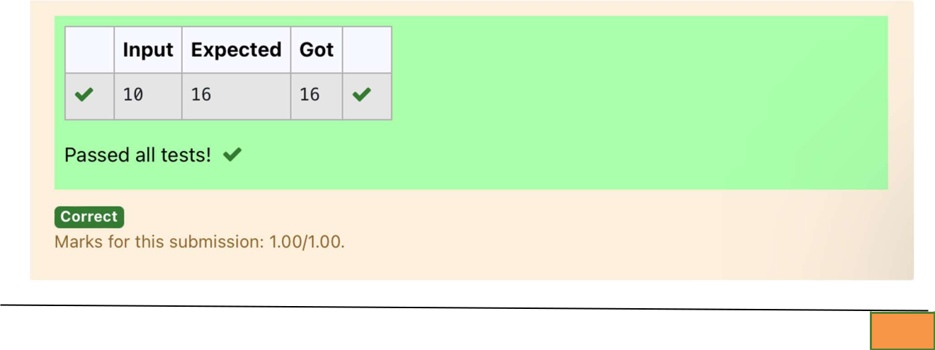

**Department of Computer Science and Engineering | Rajalakshmi Engineering College**

**.**

**Ex. No.** **:** **4.5** **Date: 12.04.2024**

**Register No.: 231401100** **Name: Shree Harini S**



**Nth Fibonacci**

**Write a program to return the nth number in the fibonacci series. The value of N will be passed to the program as input.**

**NOTE: Fibonacci series looks like –**

**0, 1, 1, 2, 3, 5, 8, 13, 21, 34, 55, . . . and so on.**

**i.e. Fibonacci series starts with 0 and 1, and continues generating the next number as the sum of the previous two numbers.**

* **first Fibonacci number is 0,**
* **second Fibonacci number is 1,**
* **third Fibonacci number is 1,**
* **fourth Fibonacci number is 2,**
* **fifth Fibonacci number is 3,**
* **sixth Fibonacci number is 5,**
* **seventh Fibonacci number is 8, and so on.**

**For example:**

**Input:**

**7**

**Output**

**8**

**a=[0,1]**

**for i in range(0,100):**

**a.append(a[-1]+a[-2])**



**Department of Computer Science and Engineering | Rajalakshmi Engineering College**

**.**

**q=int(input())**

**print(a[q-1])**

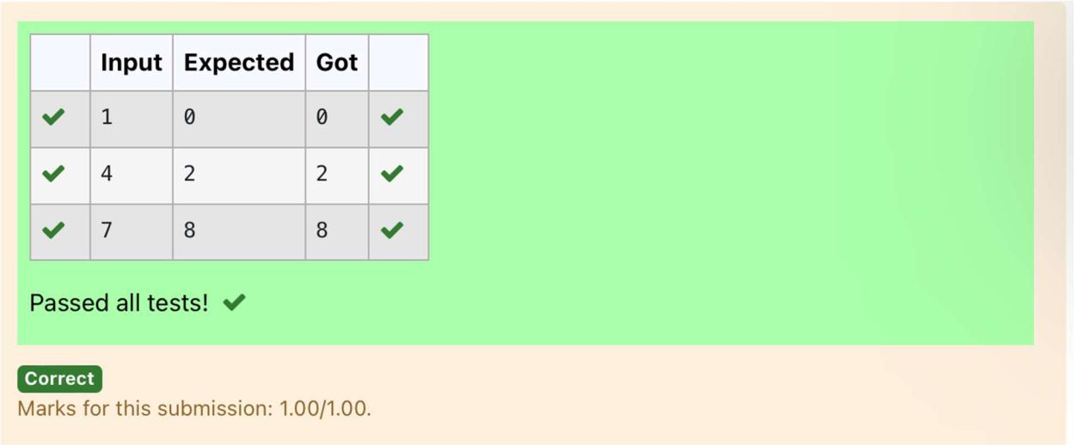

**Department of Computer Science and Engineering | Rajalakshmi Engineering College**

**.**

**Ex. No.**

**:**

**4.6**

**Date: 12.04.2024**

**Register No.: 231401100**

**Name: Shree Harini S**



**Disarium Number**

**A Number is said to be Disarium number when the sum of its digit raised to the power of their respective positions becomes equal to the number itself. Write a program to print number is Disarium or not.**

**Input Format:**

**Single Integer Input from stdin.**

**Output Format:**

**Yes or No.**

**Example Input:**

**175**

**Output:**

**Yes**

**Explanation**

**1^1 + 7^2 +5^3 = 175**

**Example Input:**

**123**

**Output:**

**No**

**For example:**



**Inpu Resul**

**t** **t**



**175 Yes**



**123** **No**



**import math**



|  |  |
| --- | --- |
| **Department of Computer Science and Engineering | Rajalakshmi Engineering College** | **.** |
|  |  |



**n=int(input())**

**a=len(str(n))**

**sum=0**

**x=n**

**while(x!=0):**

**r=x%10**

**sum=int(sum+math.pow(r,a))**

**a-=1**

**x=x//10**

**if(sum==n):**

**print("Yes")**

**else:**

**print("No")**

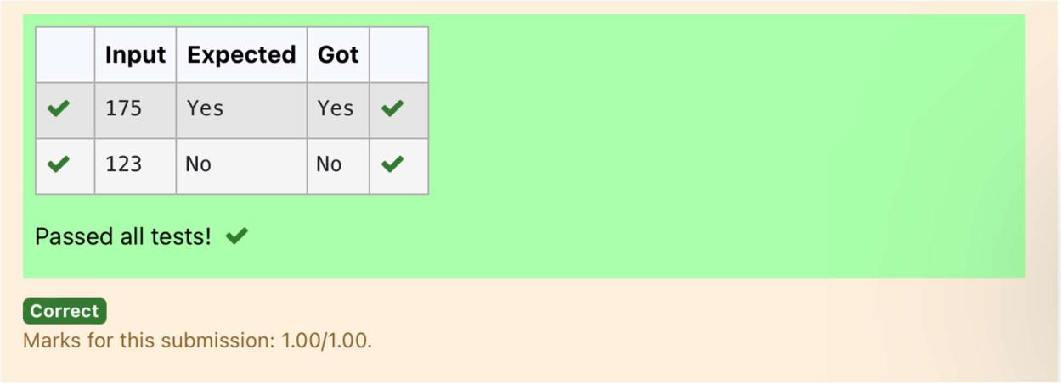

**Department of Computer Science and Engineering | Rajalakshmi Engineering College**

**.**

**Ex. No.** **:** **4.7** **Date: 12.04.2024**

**Register No.: 231401100** **Name: Shree Harini S**



**Sum of Series**

**Write a program to find the sum of the series 1 +11 + 111 + 1111 + . . . + n terms (n will be given as input from the user and sum will be the output)**

**Sample Test Cases**

**Test Case 1**

**Input**

**4**

**Output**

**1234**

**Explanation:**

**as input is 4, have to take 4 terms.**

**1+11+111+1111**

**Test Case 2**

**Input**

**6**

**Output**

**123456**

**For example:**

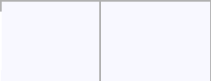

 **Input Result**



 **3**  **123**

**n=int(input())**

**b=1**

**sum=0**



**Department of Computer Science and Engineering | Rajalakshmi Engineering College**

**.**

**for i in range(1,n+1):**

**sum+=b**

**b=(b*10)+1**

**print(sum)**

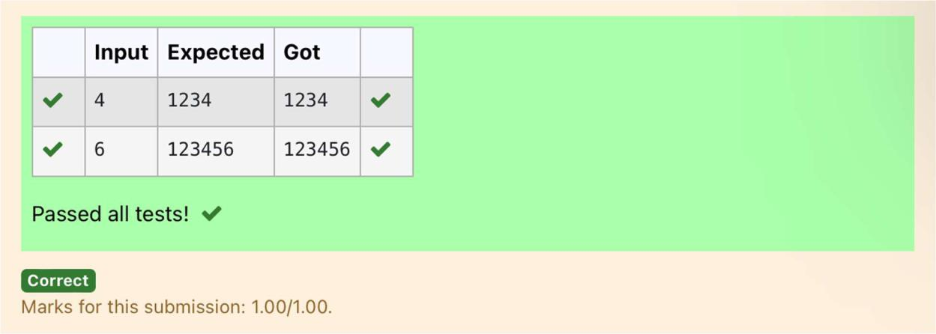

**Department of Computer Science and Engineering | Rajalakshmi Engineering College**

**.**

**Ex. No.** **:** **4.8** **Date: 12.04.2024**

**Register No.: 231401100** **Name: Shree Harini S**



**Unique Digit Count**

**Write a program to find the count of unique digits in a given number N. The number will be passed to the program as an input of type int.**

**Assumption: The input number will be a positive integer number >= 1 and <= 25000.**

**For e.g.**

**If the given number is 292, the program should return 2 because there are only 2 unique digits '2' and '9' in this number**

**If the given number is 1015, the program should return 3 because there are 3 unique digits in this number, '1', '0', and '5'.**

**For example:**



|  |  |
| --- | --- |
| **Input** | **Result** |
| **292** | **2** |
| **1015** | **3** |



**a=int(input())**

**b=[]**

**while a>0:**

**c=a%10**

**a=a//10**

**b.append(c)**

**b=list(set(b))**

**print(len(b))**



**Department of Computer Science and Engineering | Rajalakshmi Engineering College**

**.**

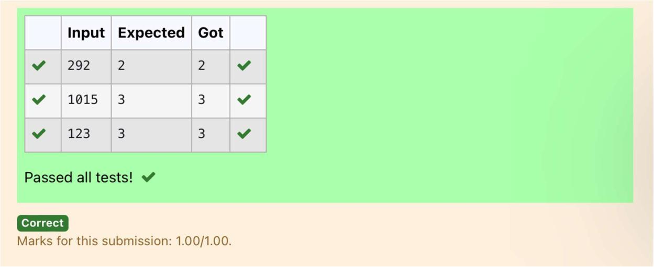

**Department of Computer Science and Engineering | Rajalakshmi Engineering College**

**.**



**Ex. No.** **:** **4.9** **Date: 12.04.2024**

**Register No.: 231401100** **Name: Shree Harini S**



**Product of single digit**

**Given a positive integer N, check whether it can be represented as a product of single digit numbers.**

**Input Format:**

**Single Integer input.**

**Output Format:**

**Output displays Yes if condition satisfies else prints No.**

**Example Input:**

**14**

**Output:**

**Yes**

**Example Input:**

**13**

**Output:**

**No**

**a=int(input())**

**flag=0**

**for i in range(10):**

**for j in range(10):**

**if(i*j==a):**

**flag=1**

**break**

**if(flag==1):**

**print("Yes")**

**else:**

**print("No")**



**Department of Computer Science and Engineering | Rajalakshmi Engineering College**

**.**

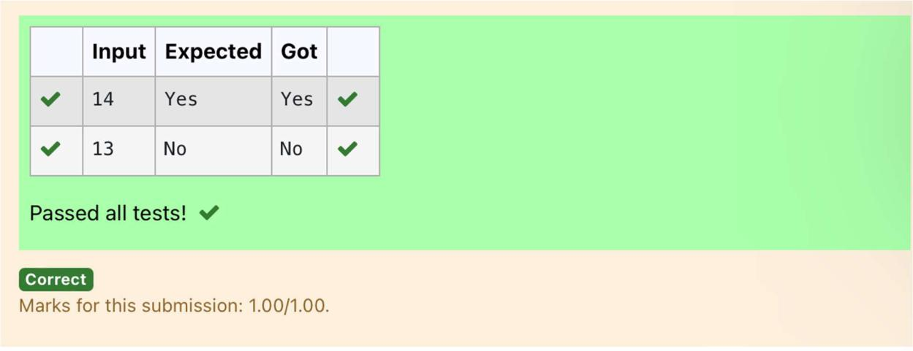

**Department of Computer Science and Engineering | Rajalakshmi Engineering College**

**.**



**Ex. No.** **:** **4.10** **Date: 12.04.2024**

**Register No.: 231401100** **Name: Shree Harini S**



**Perfect Square After adding One**

**Given an integer N, check whether N the given number can be made a perfect square after adding 1 to it.**

**Input Format:**

**Single integer input.**

**Output Format:**

**Yes or No.**

**Example Input:**

**24**

**Output:**

**Yes**

**Example Input:**

**26**

**Output:**

**No**

**For example:**

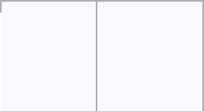

 **Input Result**



 **24**  **Yes**

**import math**

**n=int(input())**

**a=n+1**



**Department of Computer Science and Engineering | Rajalakshmi Engineering College**

**.**

**sr=int(math.sqrt(a))**

**if(sr*sr==a):**

**print("Yes")**

**else:**

**print("No")**

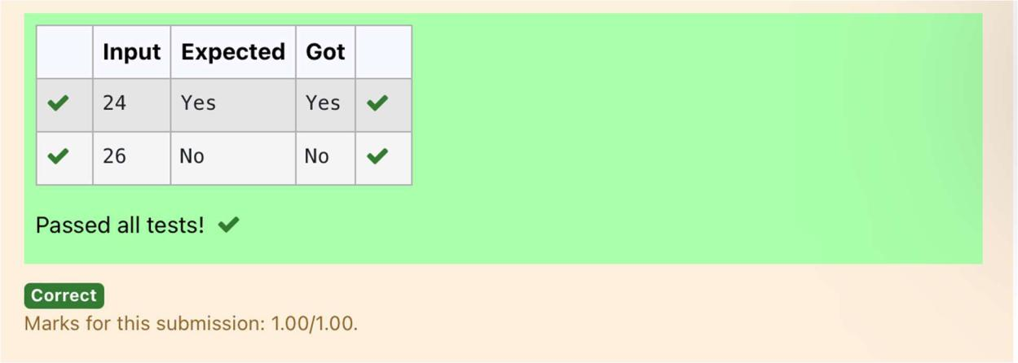

**Department of Computer Science and Engineering | Rajalakshmi Engineering College**

**.**